

National University of Sciences & Technology

**School of Mechanical and Manufacturing Enginering**

**Fundamentals of Programming Lab**

**Mechanical Engineering 15**

**Section B**

**Lab manual 5 Lab tasks**

|  |  |
| --- | --- |
| **Submitted by** | **Muhammad Shahzeb khan** |
| **Registration #** | **479677** |
| **Submitted to** | **Lab instructor Sir Saqib** |
| **Due Date** | **27 October 2023** |

**Question 1:Convert the following while loop to a do-while loop:**

#include<iostream>

using namespace std;

int main() {

int x;// declared variable

do // started do loop

{

cout<<”enter a number:”;

cin>>x;

} while(x>0);

}

**Question 2 . Use a do while loop to make a simple calculator for two numbers. Insert buttons for it to ask again and for termination.**

#include<iostream>

using namespace std;

int main() {

//declaration of variables

int num1,num2;

char operation,repeat;

//applying do while loop

do{ // gave inputs

cout<<”enter num1”<<endl;

cin>>num1;

cout<<”enter num2”<<endl;

cin>>num2;

cout<<”press ‘p’ for addition ‘s’ for subtraction. ‘m’ for multiplication and ‘d’ for division”<<endl;

cin>>operation;

switch(operation){

// made different buttons

case ‘p’:

cout<<num1+num2;

break;

case ‘s’:

cout<<float (num1-num2);

break;

case ‘m’:

cout<<num1*num2;

break;

case ‘d’:

cout<<float (num1/num2);

break;}

// asking if he wants another service

cout<<”do you want another calculation”<<endl;

cin>>repeat;

} while(repeat==’Y’||repeat==’y’);

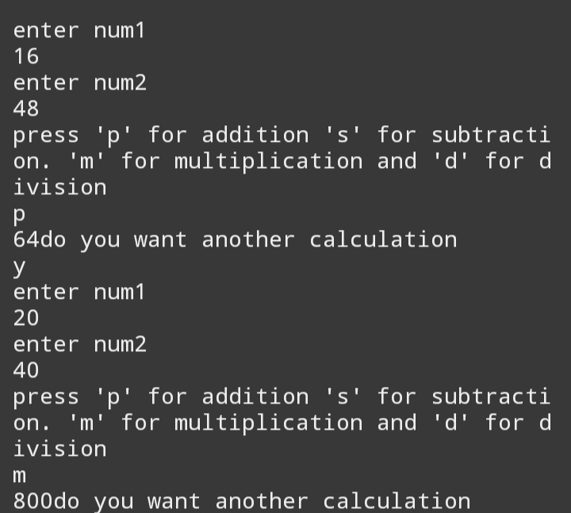}

**Question 3:Write programs with while or do while loops that compute:**

1. **The sum of all even numbers between 2 and 100 (inclusive).**

#include<iostream>

#include<iomanip>

using namespace std;

int main() {

int i;// declaring variables

int sum;

i=3;

sum=0;

while(i<100)// applied a while loop

{

if(i%2==0){ sum=sum+i;// stored sum of two even numbers in sum variable

} i++;// added increment

}

cout<<”sum is “<<sum<<endl;// printed sum

}

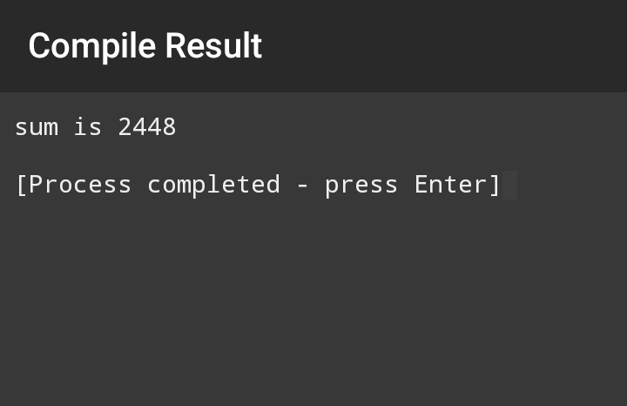

**Question 3(b)**

**The sum of all squares between 1 and 100 (inclusive).**

#include<iostream>

#include<cmath>

using namespace std;

int main () {

int a=1;

int sum=0;

while(a<101)//applied while condition for numbers less than 101

{

int b=pow (a,2);// applied power of square function for all numbers

sum=sum+b;// gave statement about sum of all numbers

a++;// increment

}cout<<sum<<endl;// printed sum

}

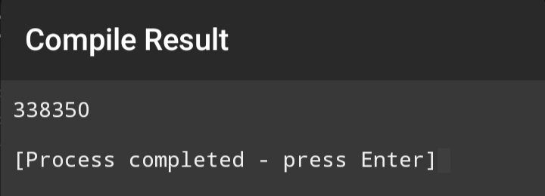

**Question 4:Write programs with while or do while loops that compute:**

1. **All powers of 2 from 20 Up to 220.**

#include<iostream>

#include<cmath>

using namespace std;

int main() { // declaration of variables

int a=0;

int b;

// applying while loop for numbers upto 20

while(a<21){

// power function for all powers of 2

b=pow(2,a);cout<<b<<endl;// printed suma++;// added increment }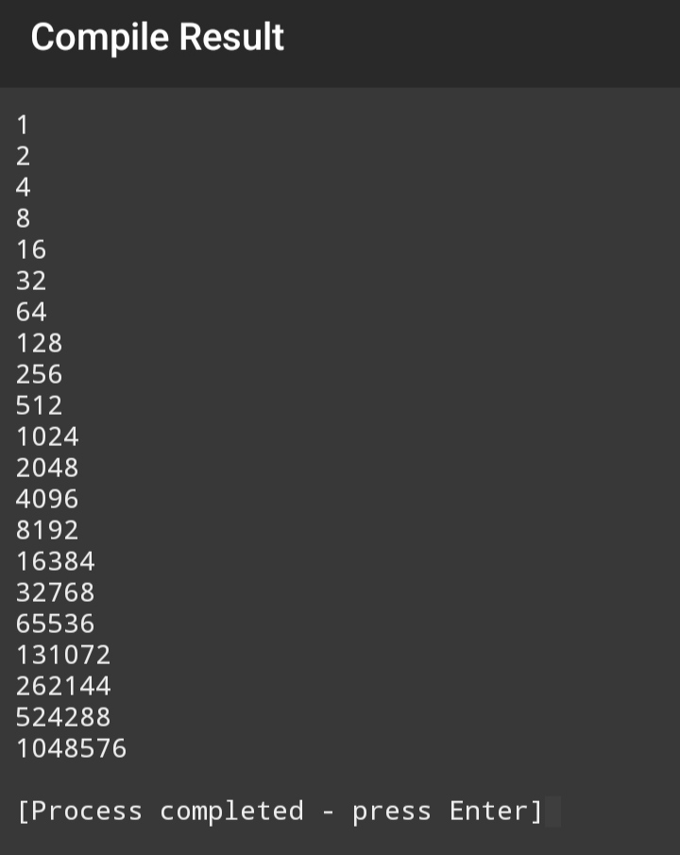}

**Question 4**

(b)**The sum of all odd numbers between a and b (inclusive), where a and b are inputs.**

#include<iostream>

using namespace std;

int main() {

int a,b;// declaring variables

cout<<”enter first number”<<endl;

cin>>a;// giving necessary inputs

cout<<”enter second number”<<endl;

cin>>b;

int sum=0;// defined values of different variables

int i=a;

while(i<b)// applied while loop for all numbers between a and b

{ if(i%2!=0)

{

sum=sum+i;// given a function for final output

}

i++;// increment

}

cout<<”sum of all odd numbers between a and b is “<<sum<<endl;// printed sum

}

